Virtual Classroom (Vlass)

High Level Design

COP 4331C, Fall, 2015

## **Modification History**

|  |  |  |  |
| --- | --- | --- | --- |
| Version | Date | Who | Comment |
| V 0.0 | 10/15/2015 | J. Casserino | Initial Draft |
| V 0.1 | 10/27/2015 | J. Bender | Rough Draft  - Added Design Architecture image |
| V 0.2 | 10/28/2015 | C. Armstrong  J. Bender  J. Casserino  M. Friedman | Rough Draft  - Added Design Issues  - Added Interfaces |

Team Name: Group 26

Team Members:

Joseph Bender [jbender94@knights.ucf.edu](mailto:jbender94@knights.ucf.edu)

Joshua Casserino [Joshua.casserino@knights.ucf.edu](mailto:Joshua.casserino@knights.ucf.edu)

Chad Armstrong [chad.armstro@knights.ucf.edu](mailto:chad.armstro@knights.ucf.edu)

Miles Friedman [milesfriedmanfl@gmail.com](mailto:milesfriedmanfl@gmail.com)

Contents of this Document

High-Level Architecture........................................................................................................3

Design Issues.........................................................................................................................4

**High-level Architecture**

The design architecture that will be used is a mix of the publish-subscribe and client-server architecture.

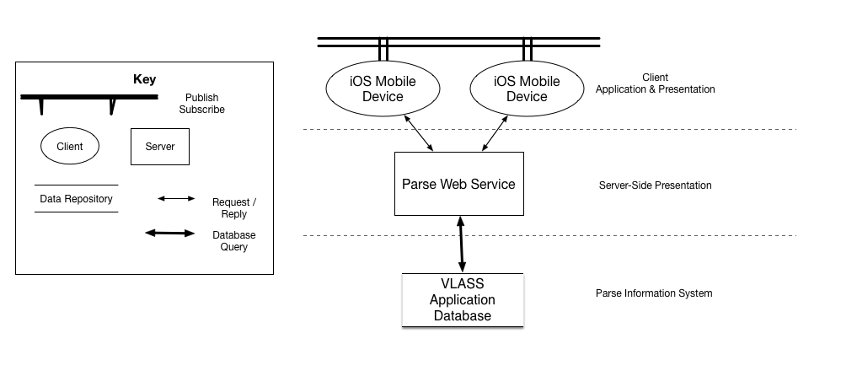

The client-server architecture is a great design for this app because each User will have access to specific data which is stored in the database (which is handled by a third party service). The addition of the publish-subscribe architecture provides the notification to all User assigned to a course.

**Interfaces**

Client (iOS Mobile Device)

- The Client is the end user that is using the iOS app. The App will send requests to the Server based off of the actions of the end user.

Server (Parse Web Service)

- The Server will handle all Client requests. Based off the access level of the Client’s profile the Server will either grant or deny the request. If granted the Server will access the database to retrieve the data. If denied the Server will send a notification back to the Client that the request was denied.

Database (Parse Information Service)

- The database is where all the information for the system will be stored. This interface is only accessible from the Server.

**Design Issues**

Design issues that affect our project include reliability, reusability, maintainability, testability, performance, portability, and security. No prototypes will be needed to evaluate this App, as the current App will be tested in the process of being built.

**Reliability**

The software design momentously aided in this projects reliability. By checking and testing every milestone and feature along the way that project became stable very early in the coding process. This was the biggest deciding factor in the decision in using the V-Model design.

**Reusability**

Since the Vlass app is by theory infinitely scalable it was required that the program reused as much code as possible. This is incredibly hard as the app is also very versatile. The project was actually scaled back, to have less features than originally planned. This was to ensure that working functions and features were reusing as much code as possible.

**Maintainability**

While the Vlass classroom app was developing the need for maintainability of the code has been apparent. With the majority of data entered and maintained by casual computer users the odds for incorrect or unsupported data input is high. To combat this issue the project team decided that an Admin user would take a Superuser role that can lessen or even prevent minor and common errors in the system.

**Testability**

The V – Model software design requires testing and checking of the project to complete each milestone. Because of that demand the code was designed to be test as individual functions and as a whole. Another factor that has increased the testability of the project was the reusability of the code. If the code is significantly reused you can test a small number of functions in a greater number of ways.

**Performance**

Performance for this application will be divided into client side performance and server side performance. Client side will depend on user's connection and device, while server side will be based on server and database performance, which will be optimized.

**Portability**

Due to application's specific platform (iOS), this application will not be portable to any other system at this time.

**Security**

Since Vlass will store data entered by users it is required to limit access to the database to only the user’s assigned data. During the profile creation the user will be assigned an ID number that limits the data that user can access. All roles but the Admin will have a limit to which data to accessible.

**Design Trade-Offs**

The Vlass app will use a combination of Client-Server and Publish-Subscribed architectural styles. This combination actually matches the scope of the app perfectly with no design trade-offs.

**What Technical Issues Are Expected**

Learning the how to use the web service Parse and Swift for coding an iOS app.

**How Will The Technical Issues Be Solved**

The project sections were split up among the group members. Each member would then start reading and learning about their project section’s requirement (i.e. swift/coding, APA/documentation, parse/database/service). That member would then be seen as the lead for that aspect of the project.

**The Rationale for Selecting this Architecture**

This architecture was chosen because it had very few draw backs in comparison to the other architecture options. The client-server architecture covers all needs of this system and the the publish-subscribe architecture includes the function of notifying the Users assigned to the course. This feature is seen as a key component to the app’s successfulness.

**Risks**

The potential risks for the Users of the system are;

Security: Since User data is stored on a database it is possible for that data to be obtained by other persons. This

Reliability: Like all systems, this program isn’t perfect and because of that it is possible for the system to crash. If this system crashes it may become unavailable to User which can affect their standing in the course. An error in the system could also cause User data to be lost, which in turn, would affect their standing in the course.